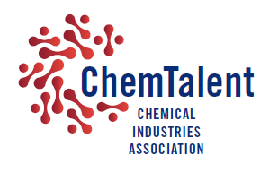
ChemTalent Influencer application form
Name …………………………………………………………………………….
Company …………………………………………………………………………
Job Title…………………………………………………………………………..
Email Address …………………………………………………………………..

Why do you want to become a CIA ChemTalent Influencer? (100 words max.)

What do you hope to gain from being a ChemTalent Influencer? (100 words max.)

